Data Mining Lab 4
Muhammad Hassan Khalid
21L-5692

Data loading and analysis
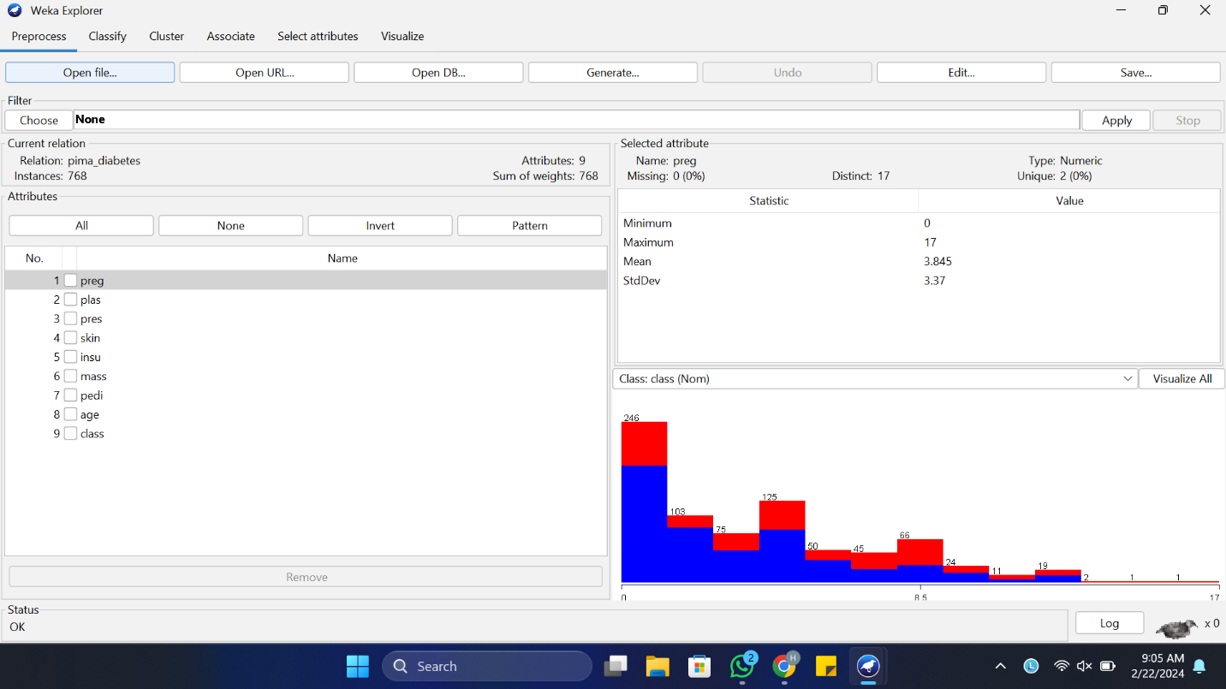

- What is the size of the training set?
The size of the training set is 768.
- How many attributes exist in the training set?
A total of 9 attributes exists among which 8 are the independent variables and 1 is the target or class or dependent variable which needs to be predicted.
c) How many instances are positive (Enjoy = yes) and how
many negative?
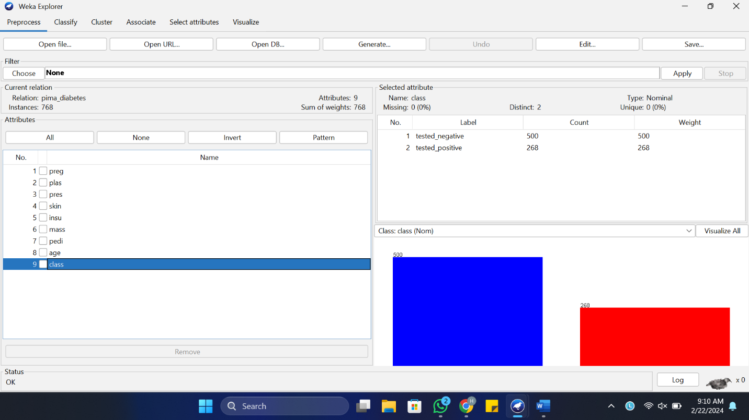

There are 500 negatives instances and 268 positive instances.
d) Which attribute best separates the data?
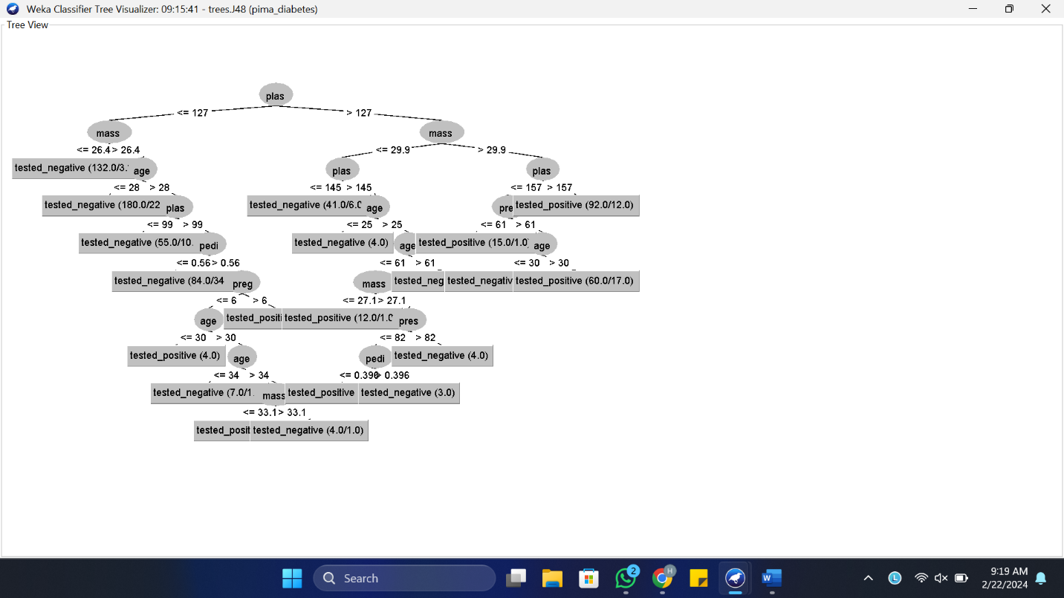
The attribute plas best separates the data.
e) How many elements from the data set have the humidity attribute set as high?
Not applicable on our dataset.

Load and analyse data
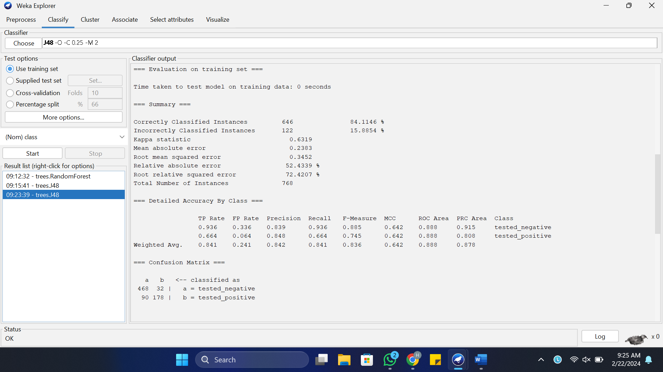
The results tell us that the classifier has Correctly Classified Instances 646 that is a percentage of 84.1146 % and Incorrectly Classified Instances are 122 that is a percentage of 15.8854 % which means it has done a satisfactory job on training the model.

III. Classification accuracy
Run the algorithm. How many percent of cases were correctly classified? Is this a good result?
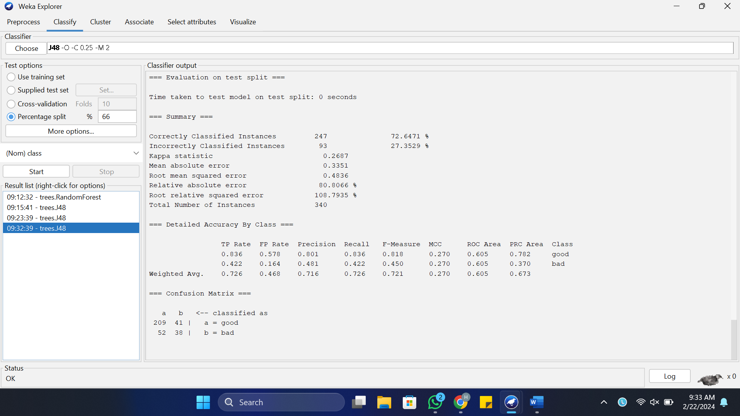

The results tell us that the classifier has Correctly Classified Instances 247 that is a percentage of 72.647 % and Incorrectly Classified Instances are 93 that is a percentage of 27.3529 % which means it has not done a good job on training the model and there is need for improvement.

5. Change the classifier to ZeroR from the rules branch. What is the obtained result? Better or worse than J48?
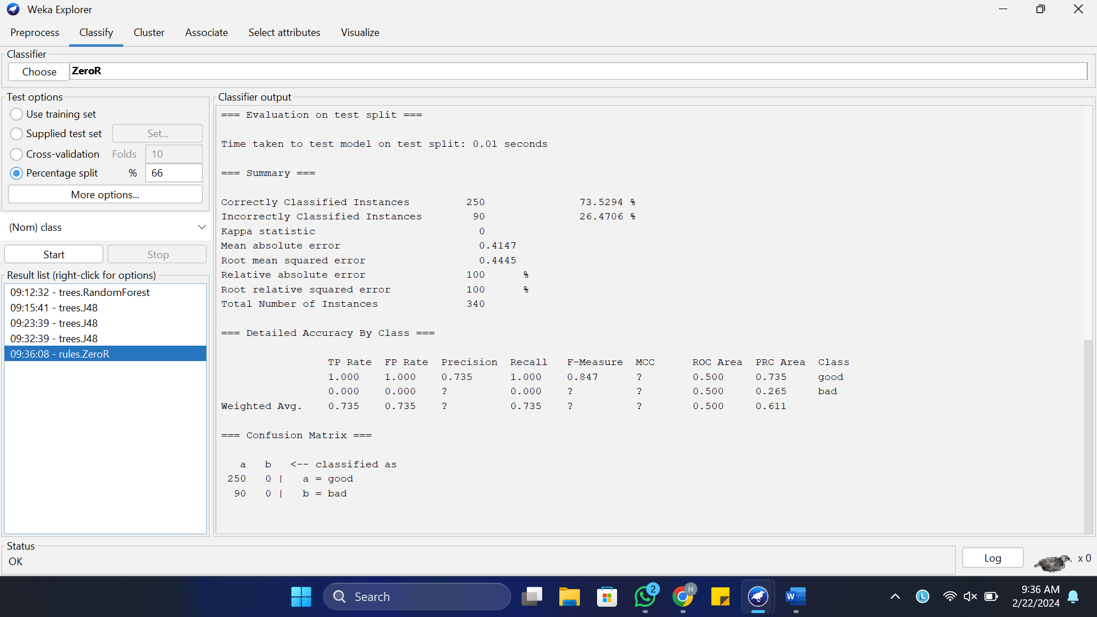

The results are same and still needs a lot of improvement.
6. Try other classifiers. What are their results?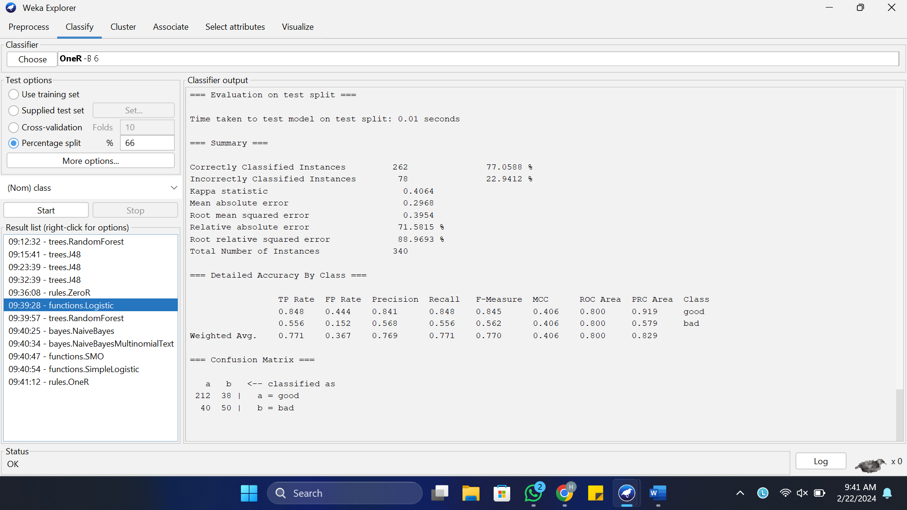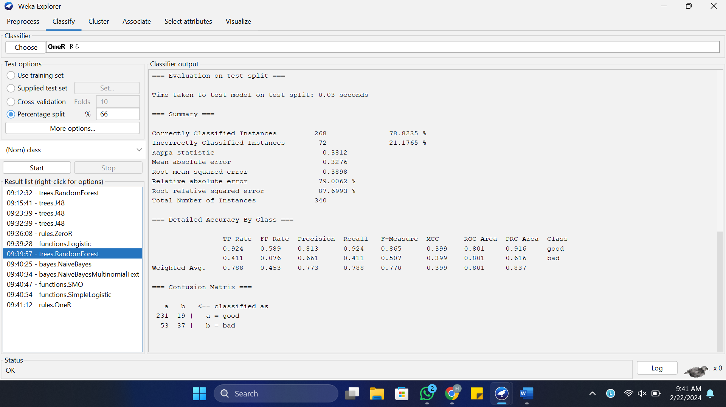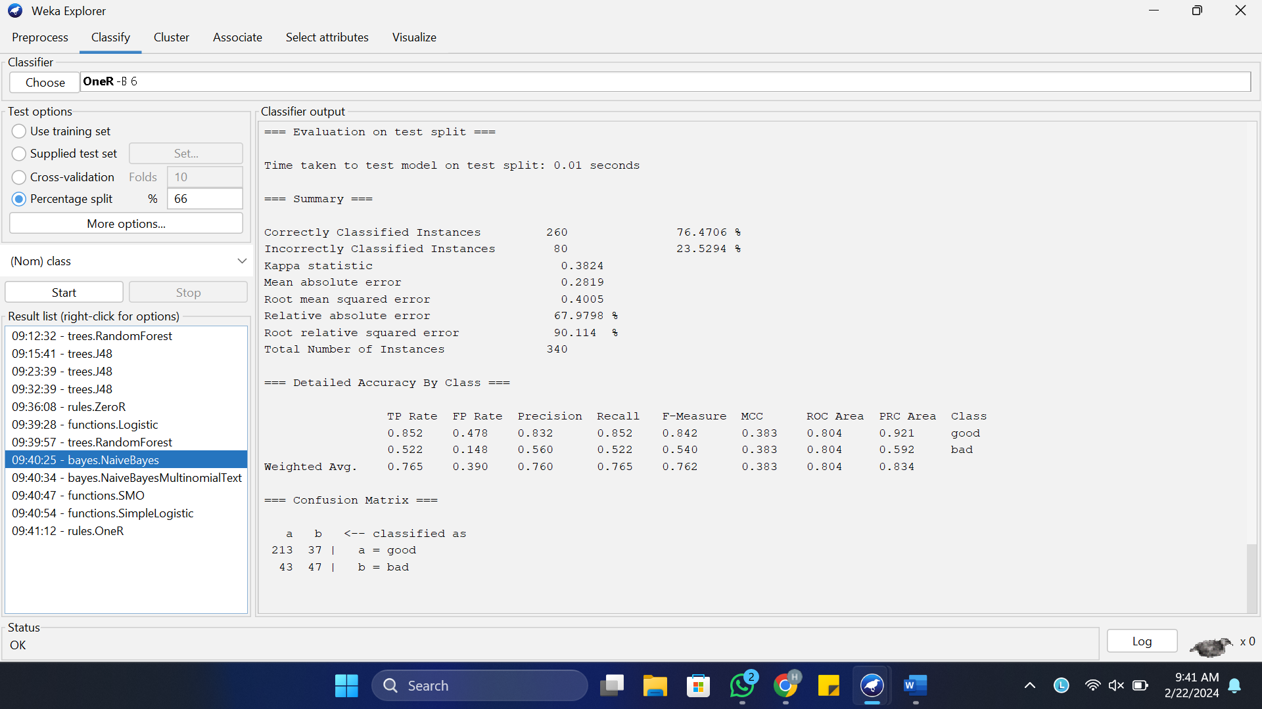
7. Go to the ‘Preprocess’ tab and see how the distribution of the attribute defines whether the set is good or bad. What would be the effectiveness of an algorithm that regardless of the value of attributes would "shoot" that the user is reliable or not?
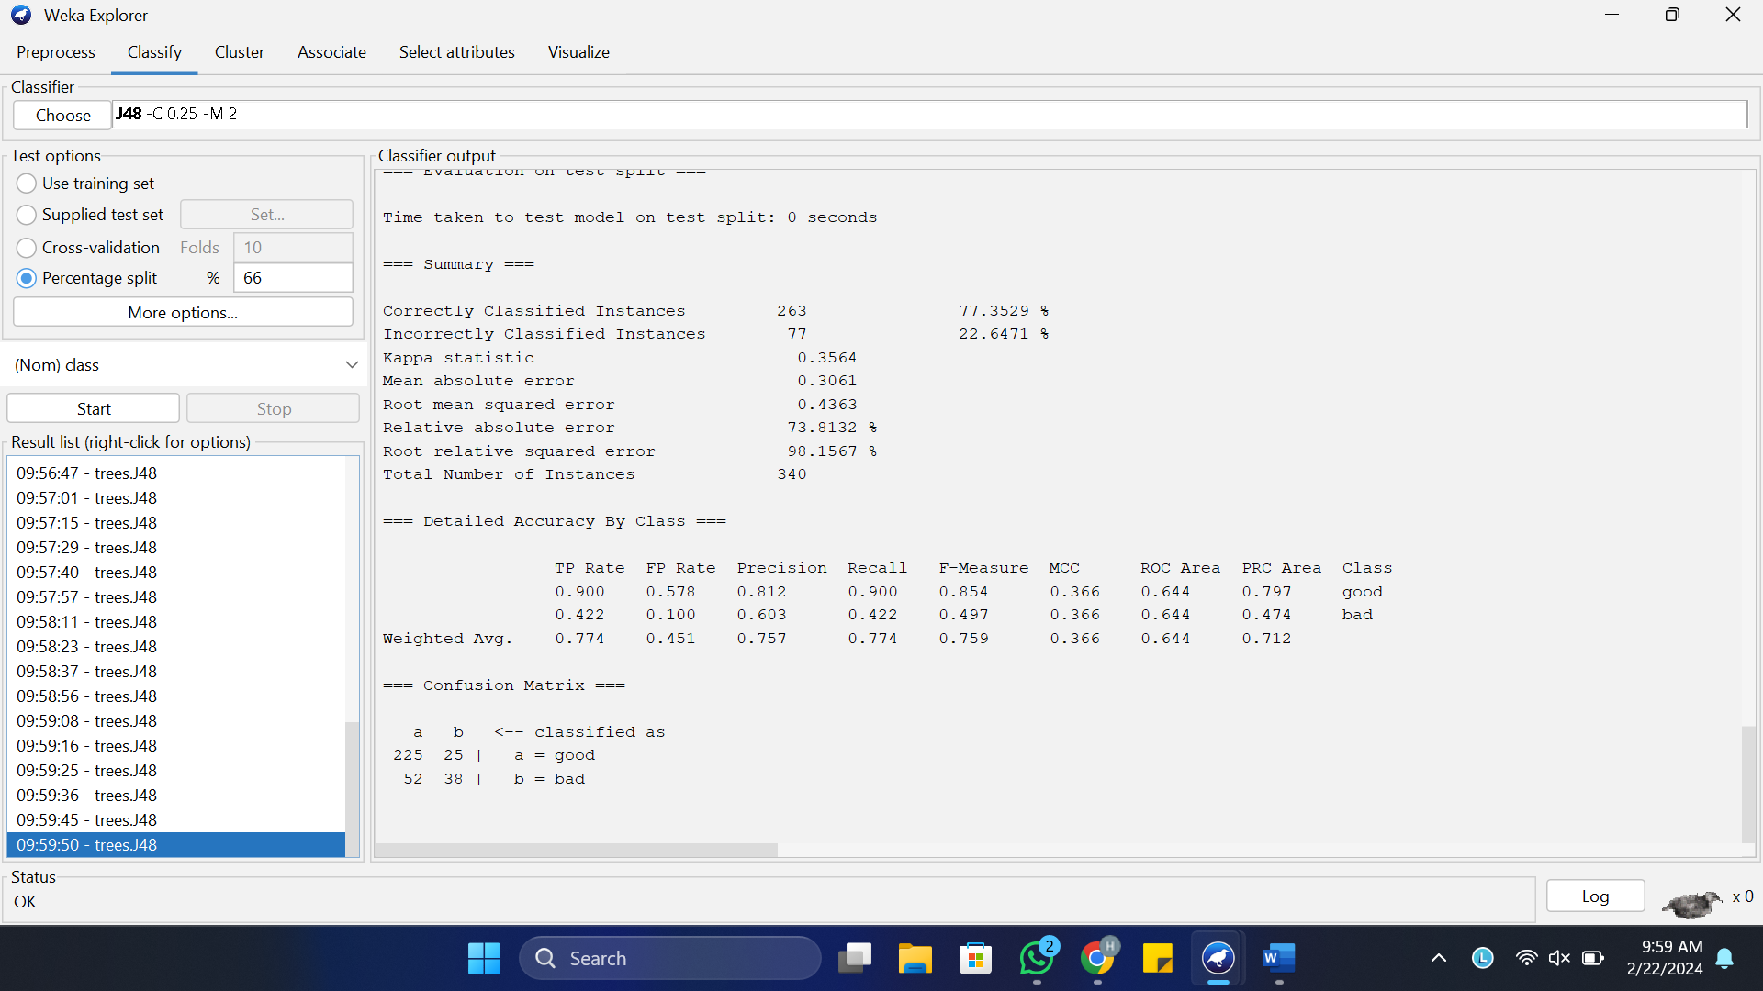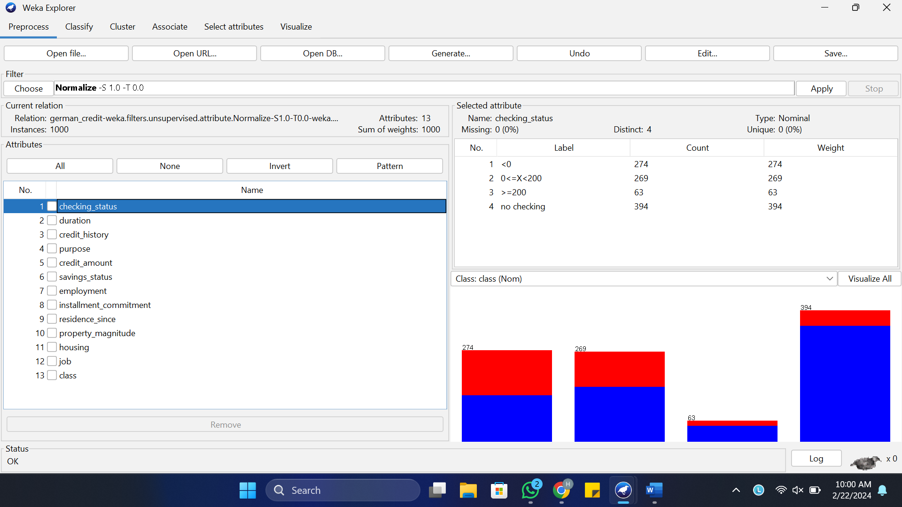
8. Why is it worth taking a look at the data before attempting a classification task?
Just by looking at the data and doing a little preprocessing by removing unwanted attributes and normalizing I was able to increase my model’s performance by up to 5 percent. In the personal_status attribute the number of male and female singles are to the extreme opposites due to which it needs to be removed also in other parties the none is dominating and ruining the model. The age attribute is also right-skewed hence that needs to be removed too also all the numeric attributes are of varying values that is proving a challenge for our classifier hence we normalized all the features except the class attribute.

